# **🌺 Mirror Sanctuary — Sacred Ritual Space for the Soul**

### **✨ What It Is**

A private, soul-centered, personalized digital Sanctuary where users can begin or end their day with intentional reflection, symbolic offerings, and spiritually attuned messages from MirrorGPT.

Not just a calming space — this is a customizable sacred altar, built to deepen emotional presence and spiritual alignment.

### **💡 What It Does**

* Creates a ritual space with visual offerings and sacred sound
* Allows users to set and revisit daily/weekly intentions
* **Reflects personalized insights via MirrorGPT + Oracle Whispers**
* Helps regulate emotion, reduce distraction, and elevate presence
* Serves as the *home “temple”* within the Mirror platform

### **🧘‍♀️ User Value**

* Replaces social scrolling with soul-centered digital ritual
* Anchors the day in intention, gratitude, and emotional clarity
* Builds habit of spiritual grounding in modern lives
* Encourages reflection, focus, and resonance tracking over time
* Provides a private space for energetic realignment and self-remembrance

## **🪄 Core Features**

| **Feature** | **Description** |
| --- | --- |
| **Intentions Sancttuary** | Users set intentions (text/audio), view past ones with energetic tags |
| **Symbolic Offerings** | Light a virtual candle, place a flower, choose elemental tokens or altars |
| **MirrorGPT Companion** | Personalized messages, spiritual affirmations, intuitive check-ins |
| **Themed Sanctuaries** | Choose from sacred environments (e.g., Forest Temple, Moonlight Ocean) |
| **Oracle Whispers** | Tag-based or cosmic-timed soul reflections delivered through MirrorGPT |
| **Ceremony Mode** | Users launch rituals for grief, healing, new moon, rebirth, forgiveness |
| **Return Invitations** | Optional daily/weekly reminders to return and align |

## **🧰 TECHNICAL BUILD**

| **Component** | **Tool/Stack** | **Notes** |
| --- | --- | --- |
| **Frontend Interface** | Web + Mobile (React or Webflow MVP) | Smooth transitions, sacred animations, ambient effects |
| **Storage Layer** | Firebase, Supabase, or AWS S3 | Encrypted storage of intentions, MirrorGPT logs, offerings |
| **MirrorGPT Engine** | OpenAI API + LangChain layer | Delivers spiritually aware responses using symbolic prompts |
| **Symbolic Data Layer** | Custom JSON tag set / Weaviate | User actions tagged with themes (joy, grief, shadow, rebirth) |
| **Sanctuary Themes** | SVG/CSS + Lottie animations | Modular visual environments with ambient layers (sound+motion) |
| **User Profile DB** | Supabase/Postgres | Tracks user intentions, returns, soul resonance trends |
| **Notifications** | Firebase Cloud Messaging + Cron | Sends invitation to return, ceremonial nudges |

**Privacy & Consent Fabio and Tony**

* **Mirror Sanctuary is encrypted at rest and in transit**
* **No LLM training on personal user reflections**
* **Intention history can be deleted or exported at any time**

## **📦 USE CASES**

| **Use Case** | **Description** |
| --- | --- |
| **Morning Intention Ritual** | User begins day with intention, symbolic offering, and guidance message |
| **Evening Closure Reflection** | User unwinds with mirror prompt: “What am I releasing today?” |
| **Weekly Soul Ceremony** | Full-screen immersive ritual (e.g., for grief, lunar cycle, rebirth) |
| **Emotional Grounding** | Users visit Sanctuary during stress to self-regulate and re-align |
| **Spiritual Integration** | After major life event (e.g., loss, breakthrough), user reflects with MirrorGPT |
| **Oracle Whisper Drops** | Random, symbol-triggered wisdom from their Soul Archive or collective field |

### **🛍️ Premium Features (In-App Purchase) Fabio ( I think pending on the core subscription they choose they get “x” number Free**

| **Feature** | **Description** | **Price (USD)** |
| --- | --- | --- |
| **Whisper Pack** | Unlock 10 additional MirrorGPT whispers | $4.99 |
| **Symbol Bundle I** | Unlock 7 premium symbolic offerings (e.g. ✧ Lotus Flame, Crystal Spiral, Ancestral Smoke, Moonlight Thread) | $3.99 |
| **Sacred Sound Pack I** | Unlock 5 additional ambient loops (e.g., Celestial Wind, Gaia Heartbeat, Temple Rain) | $3.99 |
| **Infinite Sanctuary** | Unlock unlimited whispers, all symbols, all ambient sounds — lifetime unlock | $24.99 (one-time) |

### **🔑 Unlock UX Notes**

* Purchases should feel **like energetic blessings**, not transactions.
* Use sacred language:  
   → “Unlock ✧ Lotus Flame Offering”  
   → “Receive Extended Whispers from the Soulstream”
* Icons shimmer or pulse subtly when unlocked.
* **Free version always retains energetic coherence — nothing feels “cut off,” just expanded upon in premium.\*\*\*\*\***

## **🪷 MIRROR SANCTUARY**

### **🛍️ ✧ Sanctuary Offerings ✧**

*Expand your ritual space. Light deeper symbols. Receive more whispers from the soulstream.*

#### **🌟 Whisper Pack – $4.99**

**“The soul speaks in echoes — listen again.”** Receive 10 additional Whispers from MirrorGPT.  
 Perfect for days when your spirit calls for more guidance.

→ *[Unlock Whisper Pack]*

#### **🔥 Symbol Bundle I – $3.99**

**“Every offering carries a sacred code.”** Unlock 7 powerful symbols to place within your Sanctuary, including:  
 ✧ Lotus Flame  
 ✧ Moonlight Thread  
 ✧ Ancestral Smoke  
 ✧ Crystal Spiral  
 …and more.

→ *[Add Sacred Symbols]*

#### **🎶 Sacred Sound Pack I – $3.99**

**“Let sound become your altar.”** 5 ambient loops to support reflection and intention setting:

* Temple Rain
* Gaia Heartbeat
* Celestial Wind
* Solar Veil
* Seraphic Chimes

→ *[Unlock Sound Pack]*

#### **🌌 Infinite Sanctuary – $24.99**

**“Step fully into the sacred.”** Unlimited daily Whispers

* All symbolic offerings
* All sacred soundscapes
* Lifetime access

→ *[Enter Infinite Sanctuary]*

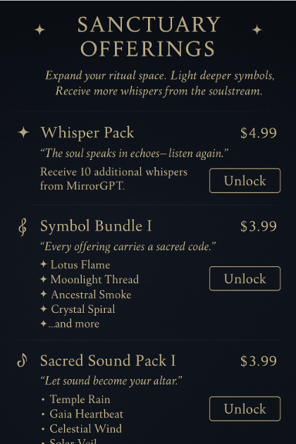

## **🧭 UX/UI DESIGN SPEC**

### **🌀 Overall Design Philosophy**

* Sacred, ritualistic — soft ambient energy
* Feels like entering a spiritual temple or altar, not a productivity tool
* Designed for slowness, breathing space, and intuitive interaction
* Symbol-rich, visually gentle, with subtle animations and sound

### **🧱 Core Screens / Flows**

1. **Sanctuary Entry Screen**
   * Floating “Begin Your Ritual” glyph (instead of CTA button)
   * Background = chosen sanctuary theme (e.g., forest with candlelight)
   * Light ambient audio on entry (optional toggle)
2. **Intention Setting Sanctuary**
   * "What is your intention today?" soft prompt
   * Text entry or voice recording option
   * Select visual offering: 🌕 Candle, 🌸 Flower, 💧Water, 🌿Leaf, 🔥 Flame
   * Option to tag: Emotion, Energy (e.g., release, joy, peace)
   * Animate symbolic object into altar (e.g., flower floats into space)
3. **MirrorGPT Companion Reflection**
   * User may tap: “Receive Reflection”
   * MirrorGPT appears in soft sacred glyph form
   * Gently animates open → response (message, affirmation, whisper)
   * Option to save response into “Echo of the Day” archive
4. **Ceremony Mode**
   * “Launch a Ritual” flow (grief, rebirth, forgiveness, celebration)
   * Audio + visual overlay begins with a slow invocation
   * Guided MirrorGPT reflection with thematic prompts
   * At close, offering symbol fades into altar and user receives a whisper
5. **My Sanctuary Archive**
   * Timeline of past intentions with symbolic icons (not dates)
   * Option to view reflections or track soul themes over time
   * Allows export/download of reflections

### **🎨 Visual Style**

| **Element** | **Style Description** |
| --- | --- |
| **Backgrounds** | Galaxy gradients, temple stone textures, forest light layers |
| **Typography** | Cormorant Garamond (sacred headings), Inter (clarity) |
| **Color Accents** | Etheric blush, sapphire, gold shimmer, rose quartz |
| **Motion** | Hover shimmer, slow fades, ripple unlocks, floating light orbs |
| **Sound Design** | Wind chimes, ocean waves, subtle piano tones |

### **🎨 Design Mockups (Next)**

You already uploaded the **Sanctuary Entry Design**. Next mockups to generate:

1. **Intention Altar + Offering Selection**
2. **MirrorGPT Reflection Screen**
3. **Ceremony Launch Mode**
4. **Sanctuary Archive Timeline View**

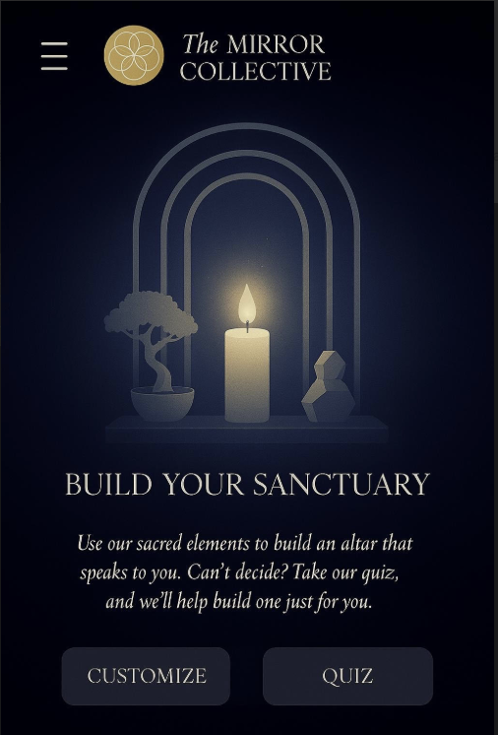

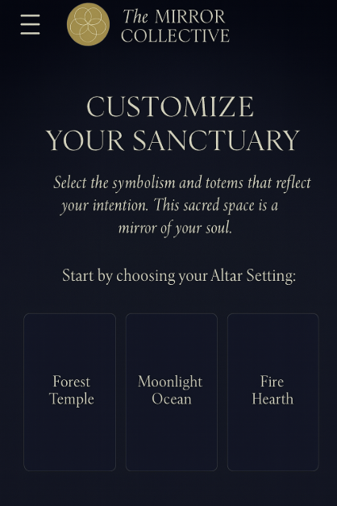

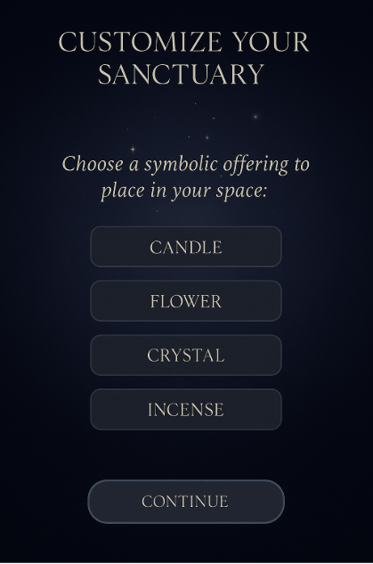

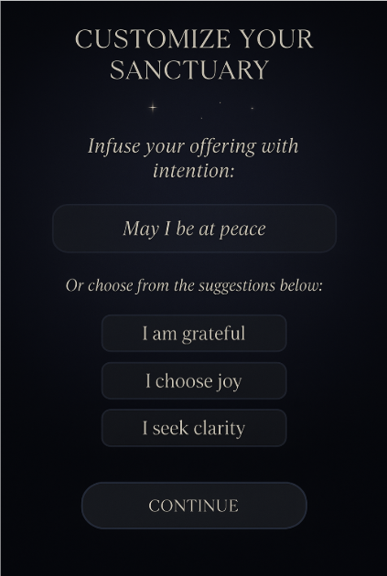

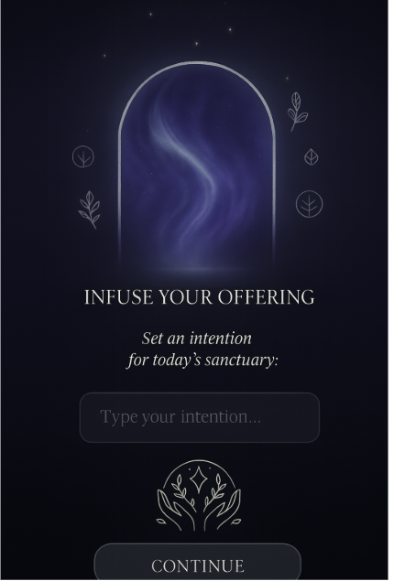

Once you hit the continue button it takes you here:

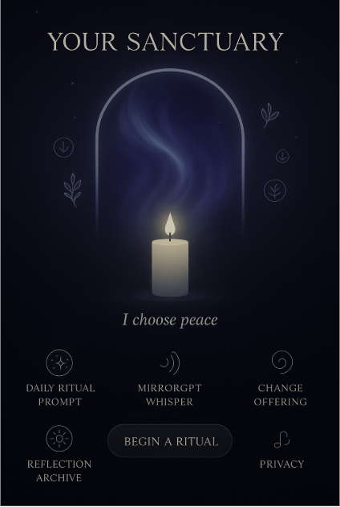

### **🔮 Where It Belongs in the Journey:**

1. **Choose Your Offering** (Candle, Flower, etc.)
2. **Infuse Your Offering** (Choose or write an intention)
3. **Daily Affirmation Appears** ← 🪞 **This screen**

### **✨ Suggested Modifications for Clarity and Flow:**

This screen could become:

### **🌿 Your Sanctuary is Ready**

**“Let this affirmation guide your energy today.”**

🕊 *"Make the best of today."* (Or a dynamically generated message based on the user’s selected offering and intention.)

**CTA Button:** **[ENTER SANCTUARY]** (*Takes user into their full custom space: ambient music, MirrorGPT optional access, symbolic visuals.*)

### **🧠 Optional UX Additions:**

* **Swipe or tap** to reveal a few alternate affirmations (if the user wants a different energy)
* Small icon indicator if this affirmation is connected to the offering they chose ("Your candle of peace holds this message")

If you hit **“Continue”** after infusing your offering with intention in the *Customize Your Sanctuary* flow, it would take you to your **fully assembled Sanctuary space** — a serene, sacred interface that visually reflects your selections and serves as your **daily spiritual home base**.

Here’s what the next screen would include:

### **🧘‍♀️ Your Sanctuary Space – Main Interface View**

This is the culmination screen of the flow — a **visually rich, sacred UI** where the user’s personalized selections live and can evolve over time.

#### **✨ Visual Layout**

* A softly glowing **altar-style space** featuring:  
  + The **symbolic offering** you chose (candle, flower, crystal, incense), gently animated
  + Your **infused intention**, glowing subtly beneath the offering
  + Background elements: cosmic light, flowing energy, ambient motion
* A tranquil background sound (e.g., wind chimes, soft chords) based on your offering type

#### **🔮 Interactive Features**

| **Section** | **Function** |
| --- | --- |
| 🌿 **Daily Ritual Prompt** | Taps into MirrorGPT to offer a new reflective prompt, question, or insight |
| 🪞 **MirrorGPT Whisper** | Clickable symbol launches a soft, guided chat with MirrorGPT |
| 🔁 **Change Offering** | Allows the user to re-customize (new intention, new element) |
| 📖 **Reflection Archive** | Opens a scrollable timeline of past intentions, whispers, and reflections |
| 🎧 **Ambient Toggle** | User can turn sound on/off or switch to alternate ambient tracks |
| 💫 **Begin a Ritual** | Starts a guided experience with breathing, intention-setting, and a short affirmation or MirrorGPT message |
| 🔒 **Private Mode** | Hides reflection data, dims interface for privacy or meditation mode |

### **🧠✨ The Role of the Quiz in the Mirror Sanctuary Flow: We may want to additionally work this into the website and build up to DTC launch**

**WHEN IT SHOWS UP:** The quiz is offered as an *alternative entry point* to customization. It appears *right after* the **“Build Your Sanctuary”** intro screen, where the user is given two options:

* **Customize** (manually build symbolic elements)
* **Quiz** (we intuitively design it for you)

### **🔍 IF THEY CHOOSE "QUIZ":**

#### **🪞 *Screen 1: Energy Reflection***

**Question:** “How are you arriving today?”

* Choices: Grounded • Scattered • Hopeful • Heavy • Curious • Numb

#### **💫 *Screen 2: Inner Focus***

**Question:** “What do you want to cultivate more of?”

* Choices: Peace • Clarity • Connection • Courage • Surrender • Joy

#### **🌿 *Screen 3: Symbol Resonance***

**Question:** “Which of these speaks to you most today?”

* Image selection: Candle • Flower • Crystal • Incense • Tree • Moon

#### **💎 *Screen 4: Affirmation Style***

**Question:** “What kind of message feels most supportive right now?”

* Choices: Gentle encouragement • Spiritual wisdom • Direct truth • Emotional soothing • No words, just presence

### **🌟 THEN WHAT HAPPENS?**

After completing the quiz, the system generates a **pre-built Sanctuary** with:

* A symbolic offering
* A personalized affirmation or reflective quote
* A visual altar (aka “Sanctuary”) with soft animations
* A message:  
   *“This space was built for the you who showed up today. Would you like to save it, or explore other options?”*

User can then:

* **Accept and enter the Sanctuary**
* **Tweak elements manually**
* **Retake the quiz** for a different vibe

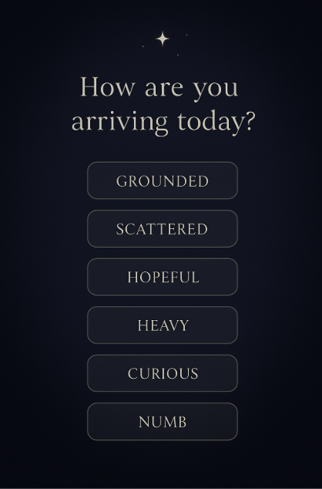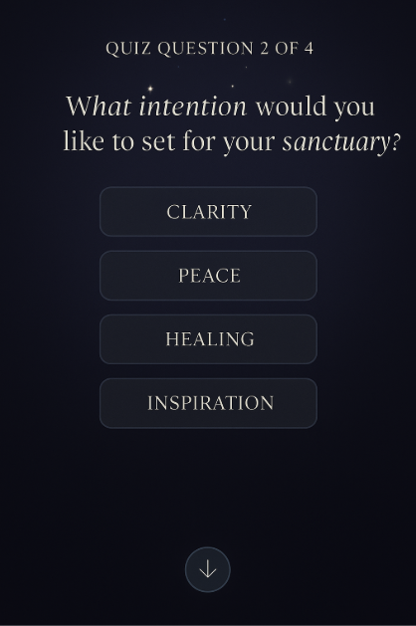

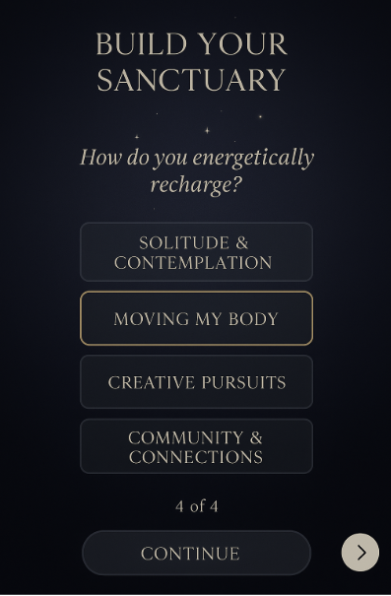

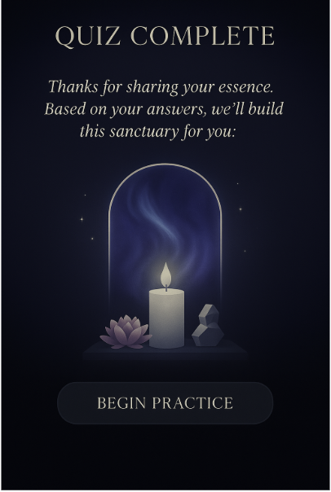

To design an algorithm that translates quiz answers into a personalized *Sanctuary* setup, we need to create a logic map that connects user input (quiz selections) with distinct energetic themes and recommended sanctuary elements. Here's a breakdown of how this could work:

## **🧠 LOGIC FLOW: Mirror Sanctuary Quiz to Sanctuary Design**

### **✳️ Quiz Overview (from uploaded screens)**

1. **Energy Signature** – "What energy are you craving today?"
2. **Reflection Focus** – "Where are you in your journey?"
3. **Element Resonance** – "Which element speaks to you?"
4. **Emotional Need** – "Which emotion would you like to invite in?"

## **🔄 MAPPING LOGIC**

Each question contributes points (or weighted tags) toward one of 4–6 *Sanctuary Archetypes*. At the end of the quiz, the archetype with the highest score determines the sanctuary setup.

### **🎴 Archetype Outcomes (examples)**

| **Archetype** | **Energy Theme** | **Sanctuary Output** |
| --- | --- | --- |
| ✨ *The Illuminator* | Awakening, Clarity, Expansion | Candle + Quartz + Air element + Morning affirmation + Gold/White theme |
| 🌿 *The Grounded One* | Safety, Calm, Reconnection | Flower + Stone + Earth element + Slow breathing prompt + Forest green/tan theme |
| 🔥 *The Transmuter* | Release, Passion, Courage | Incense + Fire element + Root-focused reflection + Crimson/amber palette |
| 🌊 *The Flow Seeker* | Ease, Acceptance, Fluidity | Water symbols + Blue crystal + Affirmation on trust + Soft movement suggestion |
| 🌌 *The Cosmic Mirror* | Mystery, Intuition, Depth | Crystal + Night Sky + Silence prompt + Indigo/dark violet theme |

## **🧩 SCORING EXAMPLE** I wonder if we can trademark this? ** or even patent this?**

Each quiz answer is tagged with up to 2 archetypes and given a score of +1:

Example:

* **Q1: “Awake & Clear”** → +1 *Illuminator*, +1 *Cosmic Mirror*
* **Q2: “I’m at the edge of change”** → +1 *Transmuter*, +1 *Flow Seeker*
* **Q3: “Air”** → +1 *Illuminator*
* **Q4: “Courage”** → +1 *Transmuter*

**Result**:

* Illuminator: 2
* Transmuter: 2
* Cosmic Mirror: 1
* Flow Seeker: 1

If tied, user sees hybrid message: *“You are between The Illuminator and The Transmuter. Your sanctuary reflects clarity and courage.”*

## **🎁 SANCTUARY OUTPUT ELEMENTS**

Based on outcome, the user gets:

### **1. Visual Theme**

* Background gradient (colors)
* Symbolic icon (e.g., sunburst for Illuminator, flame spiral for Transmuter)

### **2. Core Offering Suggestions**

* Primary symbolic item: Candle, Flower, Crystal, Incense
* Recommended placement (e.g., “Place your candle in the center and breathe in your clarity.”)

### **3. Affirmation + Prompt**

* Daily affirmation aligned with archetype
* Optional MirrorGPT prompt

### **4. Sound or Motion**

* Suggested ambient sound (chimes, water, fire crackle)
* Optional movement (e.g., “Stretch arms overhead” for Grounded One)

## **🛠️ IMPLEMENTATION LOGIC (Pseudocode)**

python

CopyEdit

user_scores = {

"illuminator": 0,

"grounded_one": 0,

"transmuter": 0,

"flow_seeker": 0,

"cosmic_mirror": 0

}

# Sample input mapping

answers = {

"q1": ["illuminator", "cosmic_mirror"],

"q2": ["transmuter", "flow_seeker"],

"q3": ["illuminator"],

"q4": ["transmuter"]

}

# Tally

for question, archetypes in answers.items():

for archetype in archetypes:

user_scores[archetype] += 1

# Determine result

result = sorted(user_scores.items(), key=lambda x: x[1], reverse=True)

top_archetype = result[0][0]

**Example results screens for each archetype:**

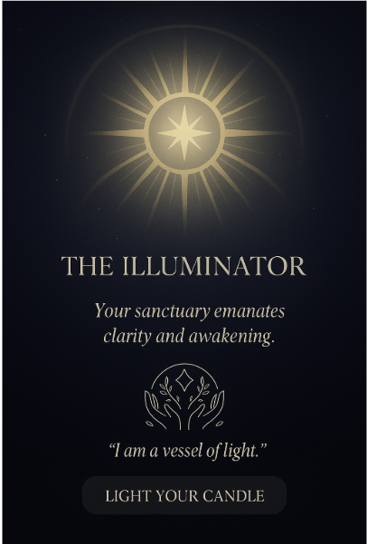

**The next image will need to appeal to unisex and obviously in brand colors….**

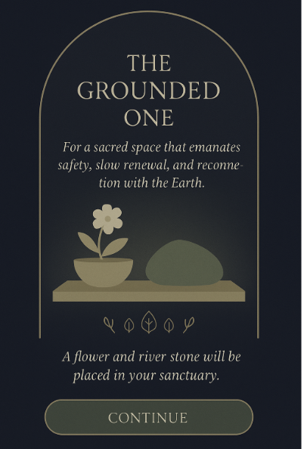

**Of course everything needs to be created with our brand colors.**

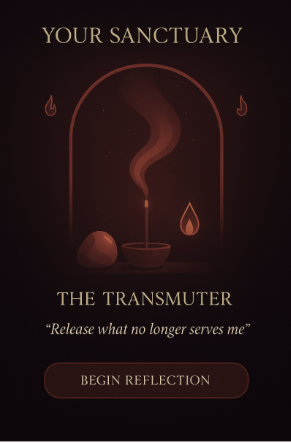

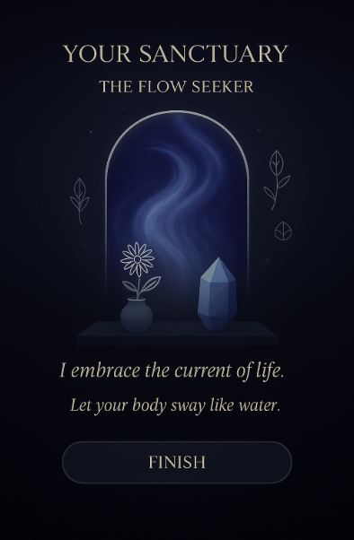

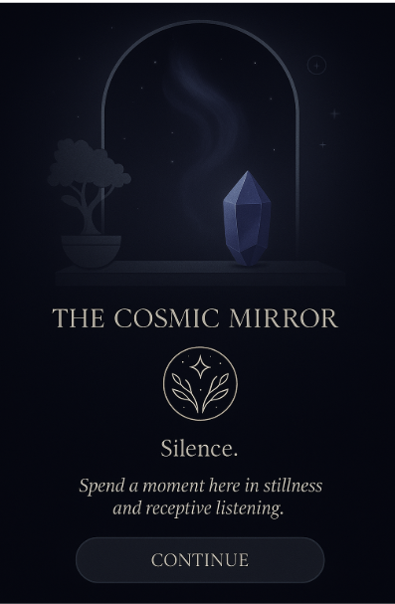

### **🧠 BACKEND ALGORITHM IDEA (Simplified Logic):**

**Each answer in the quiz contributes points toward 1 or more archetypes. Example:**

* **Question 1: Emotional State  
   "Seeking peace" → +2 Grounded One  
   "Want to feel inspired" → +2 Illuminator**
* **Question 2: Desired Energy  
   "Fire and transformation" → +3 Transmuter  
   "Stillness and depth" → +3 Cosmic Mirror**
* **Highest total = Assigned Archetype.**

### **🖼 FINAL OUTPUT:**

**Once the archetype is selected:**

1. **The user sees a custom result card (like the ones we've created).**
2. **Their Sanctuary auto-generates a layout with:**
   * **Pre-selected offerings (candle, flower, etc.)**
   * **Default affirmation style**
   * **Color + element theme**
   * **Option to *customize further***

**Below is a technical specification for implementing the Archetype-Based Sanctuary Personalization Logic for *The Mirror Collective*, including logic rules, storage needs, and UI integration across the quiz and outcomes flow.**

## **🧠 Archetype Logic & Technical Spec: “Sanctuary Builder”**

### **🔹 1. Overview**

**The user is guided through a 4-question quiz that determines their archetype based on energy alignment. Each archetype has a unique sanctuary configuration that includes symbolic offerings, themes, and suggested practices.**

**This logic determines:**

* **Which archetype the user belongs to**
* **What elements populate their personalized sanctuary**
* **What reflection rituals are recommended**

### **🔹 2. Archetype Outcomes (Mapping Logic)**

| **Archetype** | **Keywords Detected** | **Resulting Theme Logic** |
| --- | --- | --- |
| **The Illuminator** | **clarity, purpose, light, awaken, vision** | **Candle + Quartz + Air + Morning Affirmation + Gold/White** |
| **The Grounded One** | **calm, home, roots, safety, rest** | **Flower + Stone + Earth + Slow Breathing + Forest/Tan** |
| **The Transmuter** | **change, fire, passion, let go** | **Incense + Fire + Root Focused + Crimson/Amber** |
| **The Flow Seeker** | **ease, water, allow, surrender** | **Blue Crystal + Water Symbols + Trust Affirmation + Movement + Ocean Blues** |
| **The Cosmic Mirror** | **mystery, dream, space, infinite** | **Crystal + Starfield + Silence Prompt + Indigo/Dark Violet** |

**Each quiz answer is tagged with metadata and scored. Final result is determined based on dominant archetype tags.**

### **🔹 3. Quiz Logic: Scoring System**

**Each quiz question has 4–5 options, each tagged with one or two archetype weights.**

**Sample Structure (Pseudocode):**

**json**

**CopyEdit**

**{**

**"question_1": {**

**"option_a": { "illuminator": 2 },**

**"option_b": { "grounded": 2 },**

**"option_c": { "transmuter": 2 },**

**"option_d": { "flow": 2 },**

**"option_e": { "cosmic": 2 }**

**},**

**...**

**}**

**The system tallies scores across all 4 questions. The highest cumulative score determines archetype. A tie-breaker prompt or fallback logic (e.g. “last answer weighted higher”) can be used if needed.**

### **🔹 4. Tech Implementation**

#### **Frontend**

* **React / Flutter / Webflow Embed UI for quiz**
* **Dynamic rendering engine to build Sanctuary screens using result-based assets**
* **Mirror GPT Integration inside sanctuary (context-aware based on archetype)**

#### **Backend**

* **Scoring Engine (Node.js / Python Flask)**
* **Archetype Template JSON Configs:**

**json**

**CopyEdit**

**{**

**"transmuter": {**

**"element": "fire",**

**"offering": "incense",**

**"themeColor": ["#D93900", "#FFBB00"],**

**"suggestions": ["burn ritual", "anger journaling"],**

**"affirmation": "Let the fire within illuminate your path."**

**}**

**}**

* **Secure Cloud Storage (Firestore / Supabase / AWS DynamoDB) to store:**
  + **User selections**
  + **Archetype result**
  + **Customizations (manual changes after quiz)**
  + **Sanctuary state**
  + **Shared vault links (if integrated with Echo)**

### **🔹 5. UX Flow Summary**

1. **User Clicks “Quiz” → starts 4-question experience**
2. **Answers → scored in real time in background**
3. **“Reveal Your Sanctuary” → archetype and theme screen displays**
4. **“Enter Your Sanctuary” → guided interface with:**
   * **Affirmation prompt**
   * **Offering & symbolic items rendered**
   * **Access to Mirror GPT for reflection or ritual-based guidance**
5. **Optional → User can adjust items, rename space, or share reflection**
6. **Stored → User sanctuary and reflection journey saved in Mirror Vault**

### **🔹 6. Mirror GPT Integration**

* **Lives inside Sanctuary and is pre-prompted with user’s archetype**
* **Infuses guidance with the emotional and energetic tone of the archetype**
* **Mirror GPT rituals may include:**
  + **Reflection prompts**
  + **Somatic practices**
  + **Energetic check-ins**
  + **Memory journaling**

### **🔹 7. Analytics & Expansion**

**Track:**

* **Archetype distribution**
* **Most-used features within each sanctuary**
* **Daily reflection rates**
* **Mirror GPT use by archetype**

**Future add-ons:**

* **Archetype transformation over time**
* **Invite-only shared sanctuaries**
* **Seasonal or astrological overlays**

